Questions for this project:
1) Describe any challenges you encountered
First of all, I’m not very familiar with linked list, so I spent a lot of time learning about them. Though I searched on the internet for similar code to modify, I still have difficulties completing this project. However, I had completed this project by using arrays, so I would also put this into the file.
Also, I'm not very clear on how to use class and building functions, there are too many procedures I wanted to process. I tried to use global functions to simplify my code, and by doing so, I found that there is less and less code left in my class.

2) What did you learn from this programming assignment?
I learned the technique of in set, pre set and post set, and got more familiar with linked list and stack.

3) Which data structures did you use, why?
I used stack instead of queue, since stack is LIFO , it is easier to use when doing post set, which is more intuitive to me.

4) What is the time complexity of your program in terms of comparisons?
The time complexity in terms of comparison T(n)= i^2 = O{n^2}

5) Which section of code requires the greatest number of comparisons?
Postfix. Since it also needs to judge the complexity.

6) Aside from more efficient use of space, what are the reasons we use linked lists for this program versus an array?
Using linked list is easier for data to edit and store, just need to change the pointer.

Test result (using array code, since I cannot debug out my linked list one):

There are spaces in input, so I use get line to separate them.
Also, the input can be integer or capital alphabets.
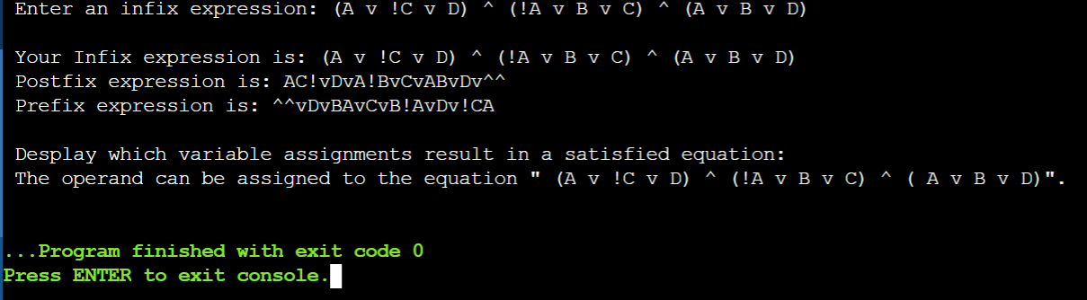

unsatisfied when using non certified input.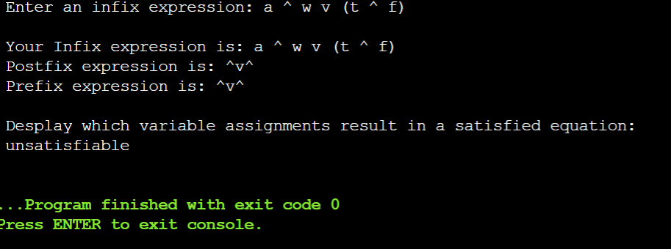

It is okay to use binary input, also the code would tell you the variables you assigned can suit which function.
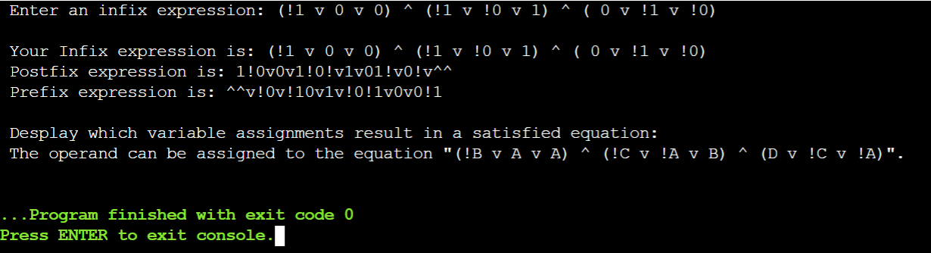

Entering the non-qualified number of input, although the code can still run, it will print out that it can not be substituted into the setted function.
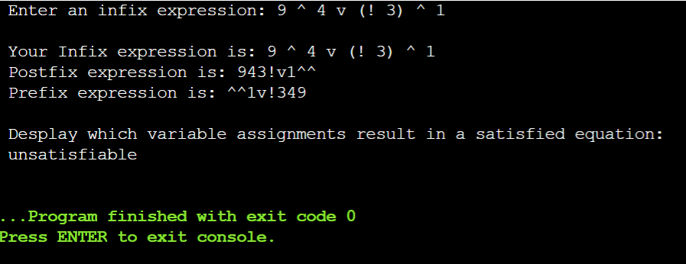

At last, without space, the code can still work.
